GREEDY Best-First Search
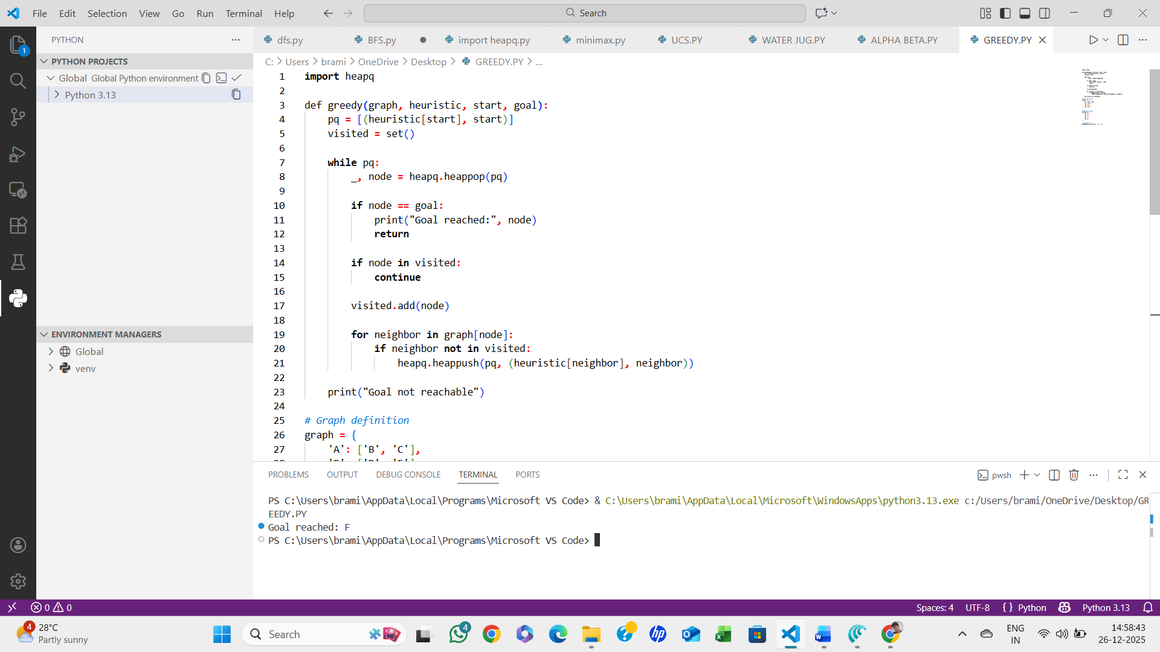

ALGORITHM:
- Start with the initial node
- Use a priority queue ordered by heuristic value
- Expand the node with the lowest heuristic
- Stop when the goal is reached

